**Omni Shop Ecommerce Solution**

1. Start Screen  
   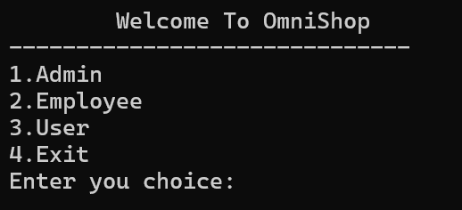
2. Admin Operations Screen  
   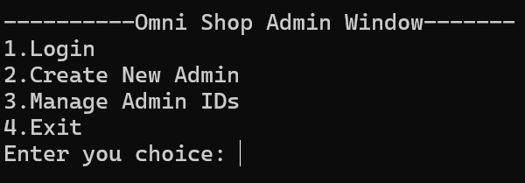
3. Admin Menu Screen  
   